Certificate of Completion
This is to certify that OBAID WASEEM SHAHBAZ AHMED, AZAM RAJPOOT, MAAZ-BIN-NADDEEMhave successfully completed their ACCP Semester I E-Project.

Submitted to: Aptech Computer Education
On
APRIL 21th, 2025

Acknowledgement
First of all we would like to thank Almighty Allah for giving us strength and ability to complete this project.
And then, we would like to express my special thanks of gratitude to our teacher Sir Tayyab who guided us on the project Kitchen Appliances, which also helped us in doing a lot of new learning and we came to know about so many new things we are really thankful to him.
We are highly thankful to Sir Tayyab for his guidance and constant supervision as well as for providing necessary information regarding the project & also for his support in completing the project.
Lastly, we would also like to thank our parents and friends who helped us a lot in finalizing this project within the limited time frame. We also express our sincere gratitude to E-Project team from Aptech Head Office, for their valuable guidance and support for the completion of this project. We earnestly hope that this project will provide all the necessary information required by the user to fulfill his/her inspiration. However, suggestion and Feedbacks for improvements will be thankfully welcomed & acknowledged.

Project Synopsis

Project Title: Unit Converter Web Application
This project is a simple and interactive unit converter built using HTML, CSS, and JavaScript.
It allows users to convert values between units like length, weight, and temperature.
The app features a clean UI, real-time conversion, and responsive design.
It is ideal for students and professionals needing quick unit conversions.

Functional Requirement

🔷 Unit Converter Web Application – Structured Overview
🏠 Home Page
A clean and modern interface for quick access to all conversion tools.

Highlighted categories for different types of unit conversions.

📂 Conversion Categories
Length
- Sub-Categories:
- Meter to Kilometer
- Inch to Centimeter
- Feet to Inches
- Yard to Meter
- Mile to Kilometer
- Weight
- Sub-Categories:
- Gram to Kilogram
- Pound to Kilogram
- Ounce to Gram
- Tonne to Pound
- Temperature
- Sub-Categories:
- Celsius to Fahrenheit
- Fahrenheit to Kelvin
- Kelvin to Celsius
- Time
- Sub-Categories:
- Seconds to Minutes
- Minutes to Hours
- Hours to Days
- Area

Problems Statement:

Many users struggle to convert units quickly and accurately across different measurement systems.
Manual conversions can be time-consuming and error-prone.
There is a need for a simple and efficient tool to handle unit conversions.
Users require an easy-to-use interface accessible from any device.
This project aims to develop a responsive web-based unit converter using HTML, CSS, and JavaScript.

Proposed System

The proposed system is a web-based unit converter built using HTML, CSS, and JavaScript.
It allows users to convert values between various units like length, weight, temperature, etc.
The interface will be clean, responsive, and easy to navigate on all devices.
It provides real-time results as the user inputs data or selects units.
The system will reduce manual calculation errors and improve user convenience.

Hardware and Software Requirements
Hardware Requirements
Processor: Intel Core i3 or higher

RAM: Minimum 4 GB

Hard Disk: 100 MB of free space

Display: Standard HD Display (720p or above)

Input Devices: Keyboard, Mouse

Software Requirements
Operating System: Windows / macOS / Linux

Browser: Google Chrome, Firefox, Edge, or any modern browser
Code Editor: VS Code / Sublime Text / Notepad++

Languages Used: HTML, CSS, JavaScript
Website Features

Website Features
Unit Conversion Functionality
Users can convert between multiple unit types (Length, Weight, Temperature, etc.).
Real-tie conversions are displayed immediately as users input values and select units.
Responsive Design.
The website is mobile-friendly and works seamlessly on desktops, tablets, and smartphones.
User-Friendly Interface
Simple and intuitive navigation with clearly labeled input fields, dropdown menus, and buttons.
Multiple Unit Categories
Users can select from various categories such as Length, Weight, Temperature, Time, and Area.
Each category contains multiple unit options for conversion.
Error Handling
Input validation ensures that only numeric values are entered.
Error messages are displayed for unsupported conversions or invalid inputs.
Conversion History (Optional)
Users can view a history of their previous conversions for easy reference.
Clear Input Button
A button that resets the input fields and clears any selected units.
Support Links
Links to an "About Us" page, user manuals, and a contact form for user support.

Flow diagram

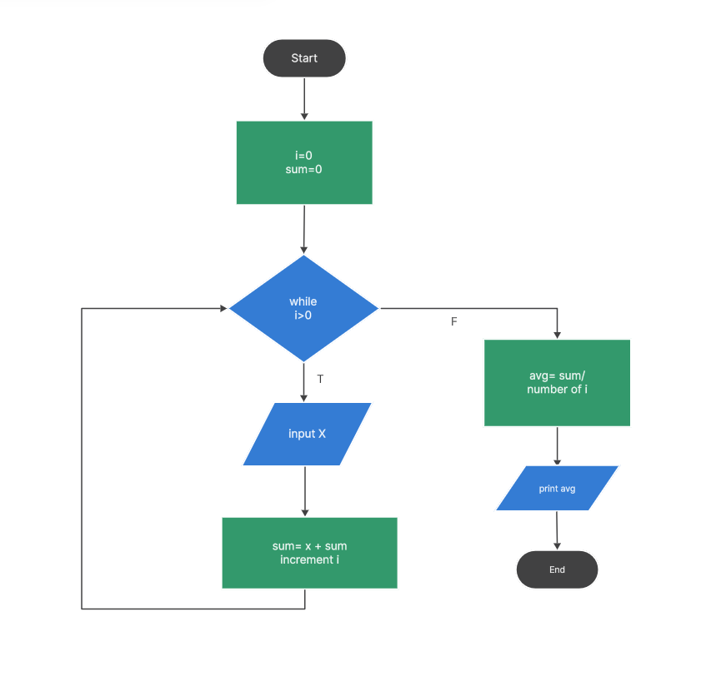

User Guide
- Homepage (landing Page)
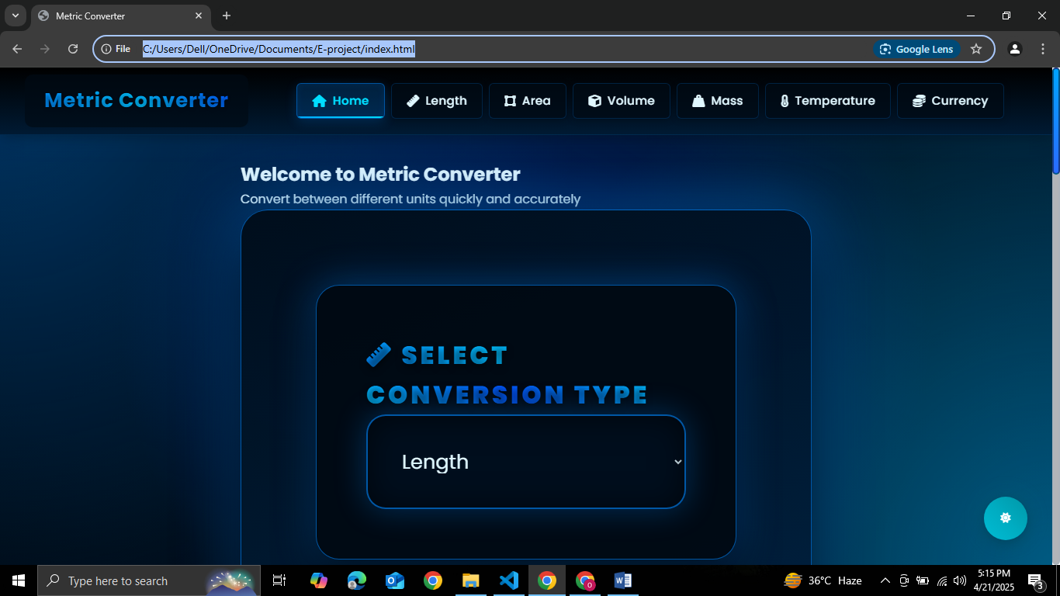
- ABOUT US
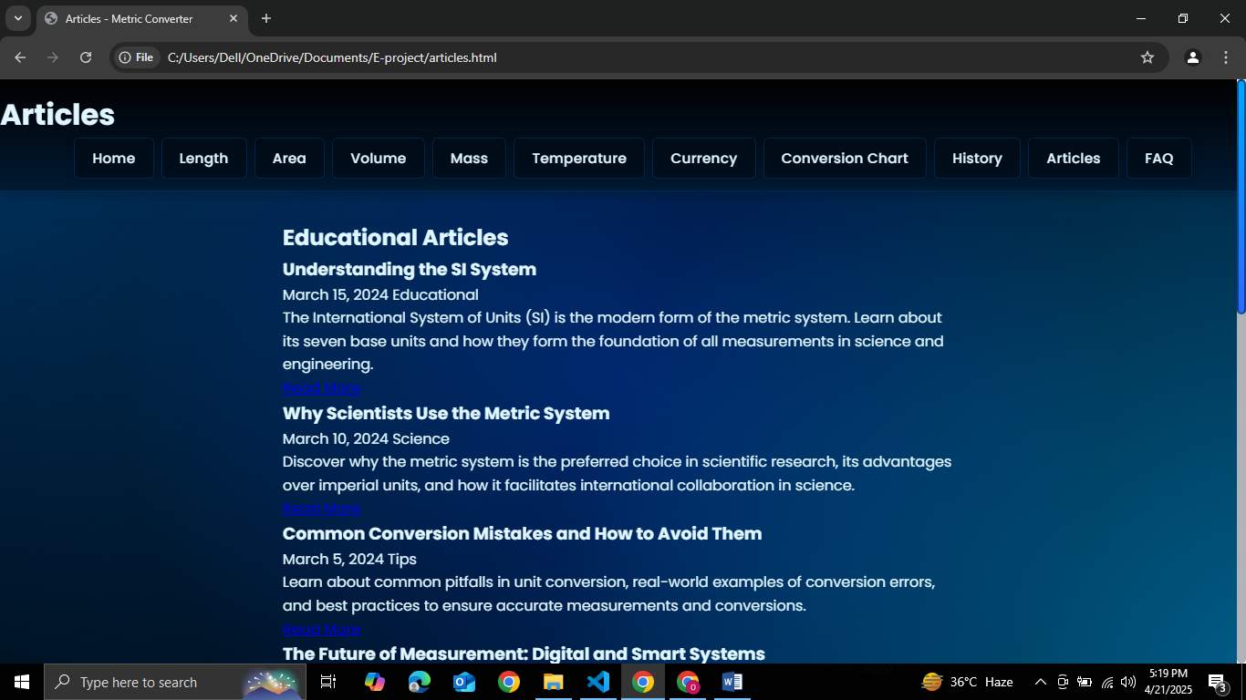
- Length Converter
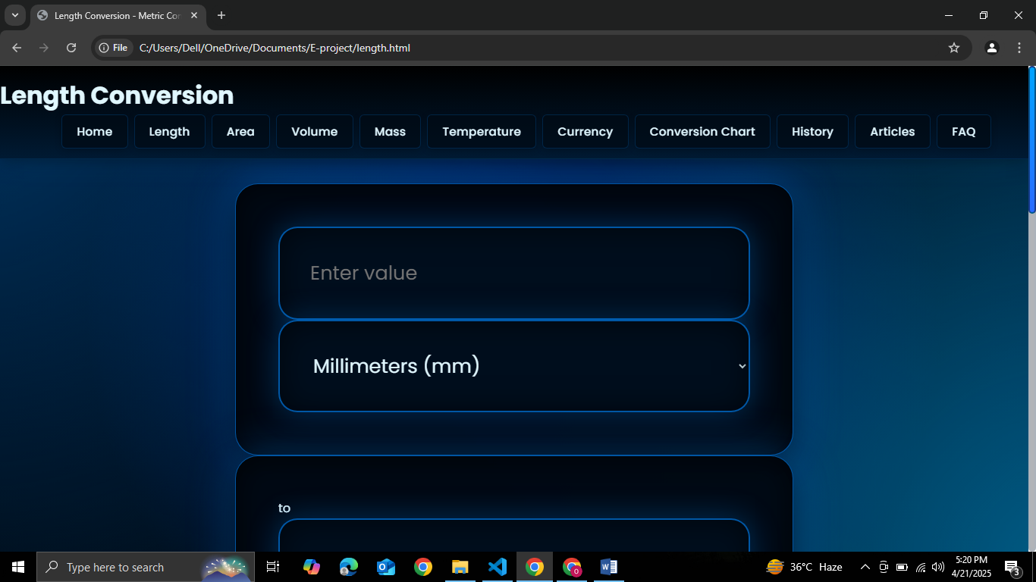
- Mass Converter
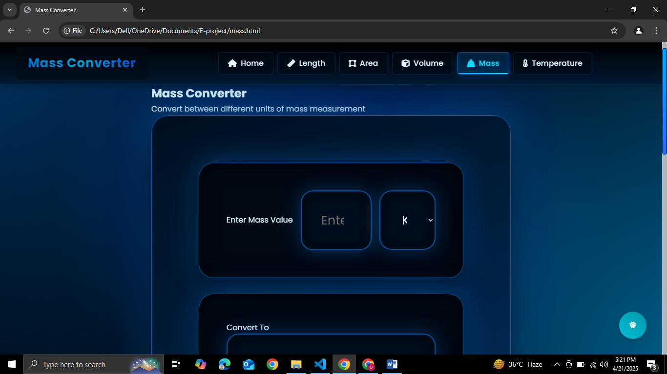
- Area Converter
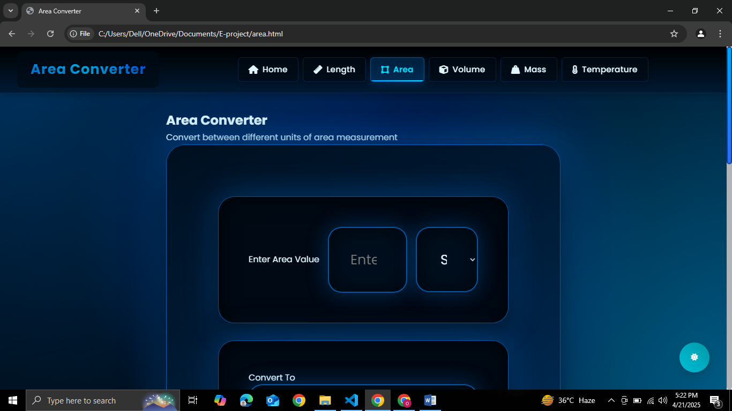
- Volume Converter
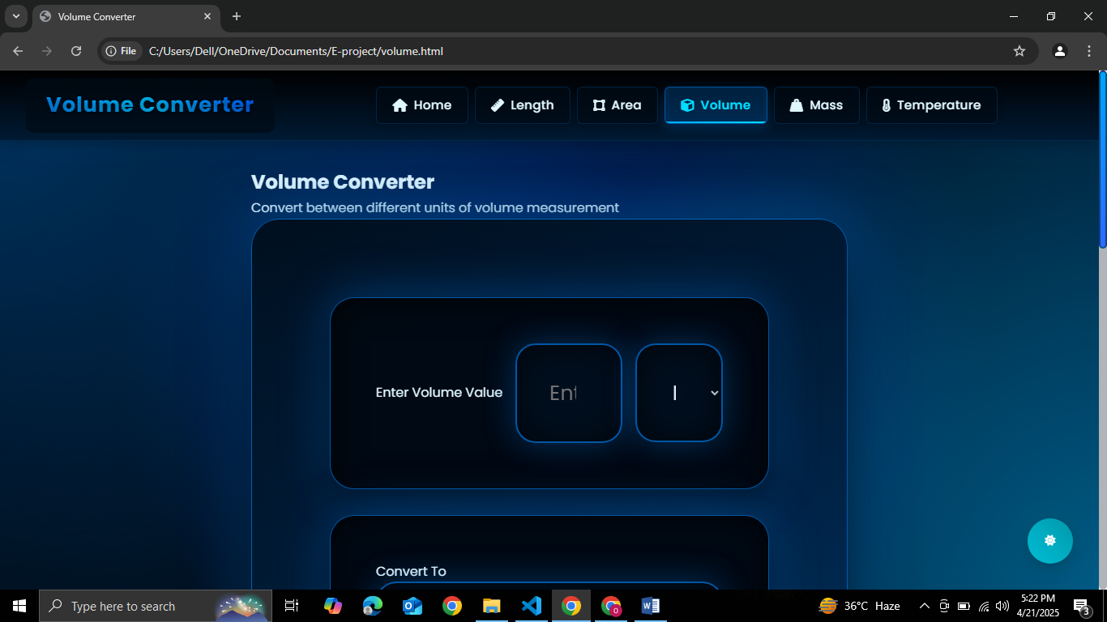
- Temperature Converter
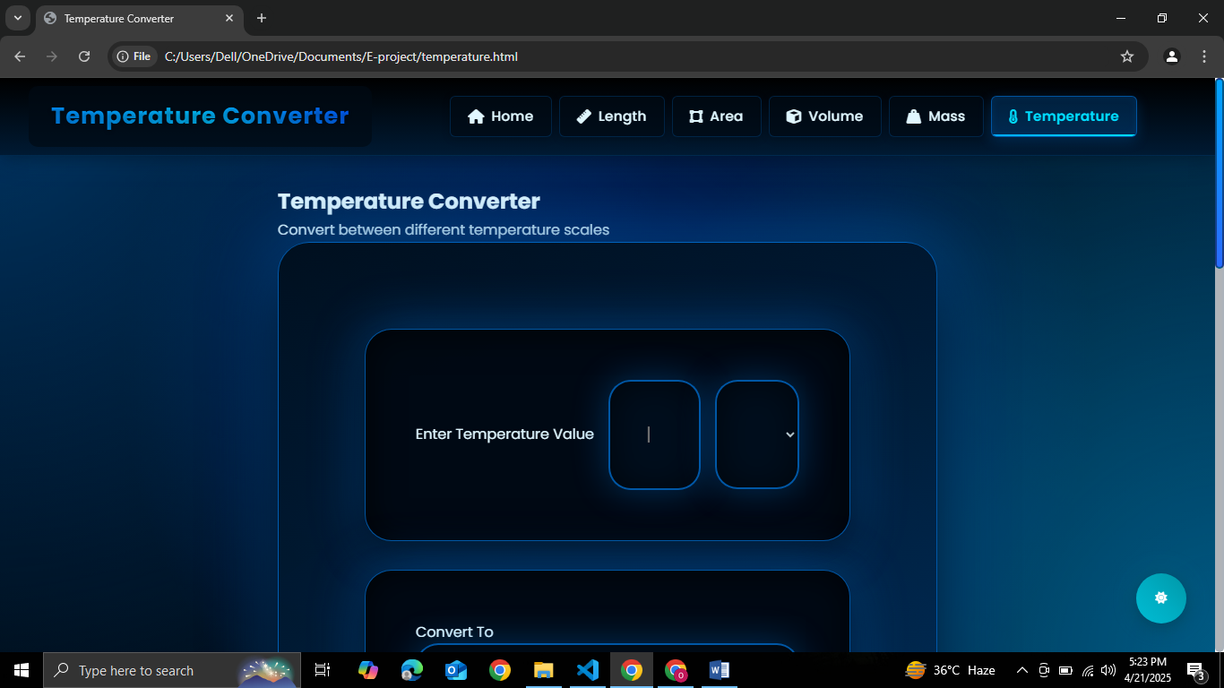
Developer’s Guide
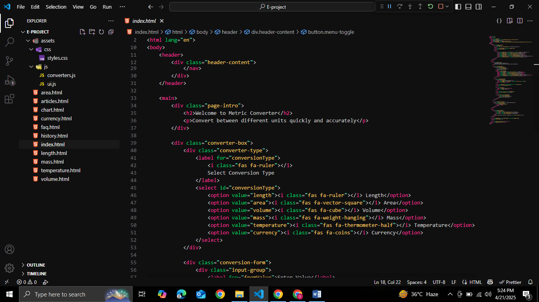

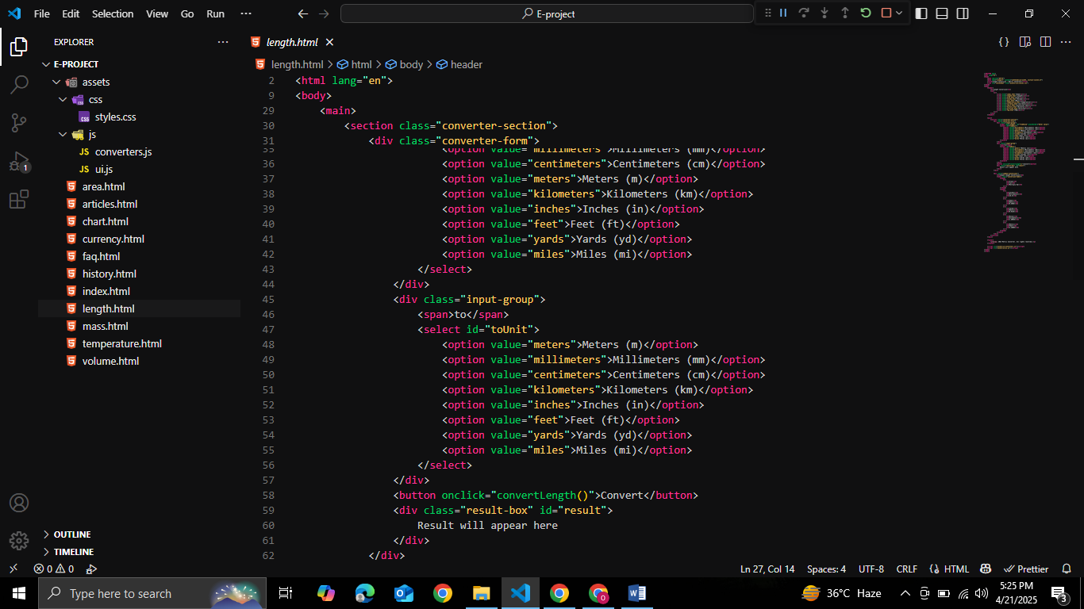

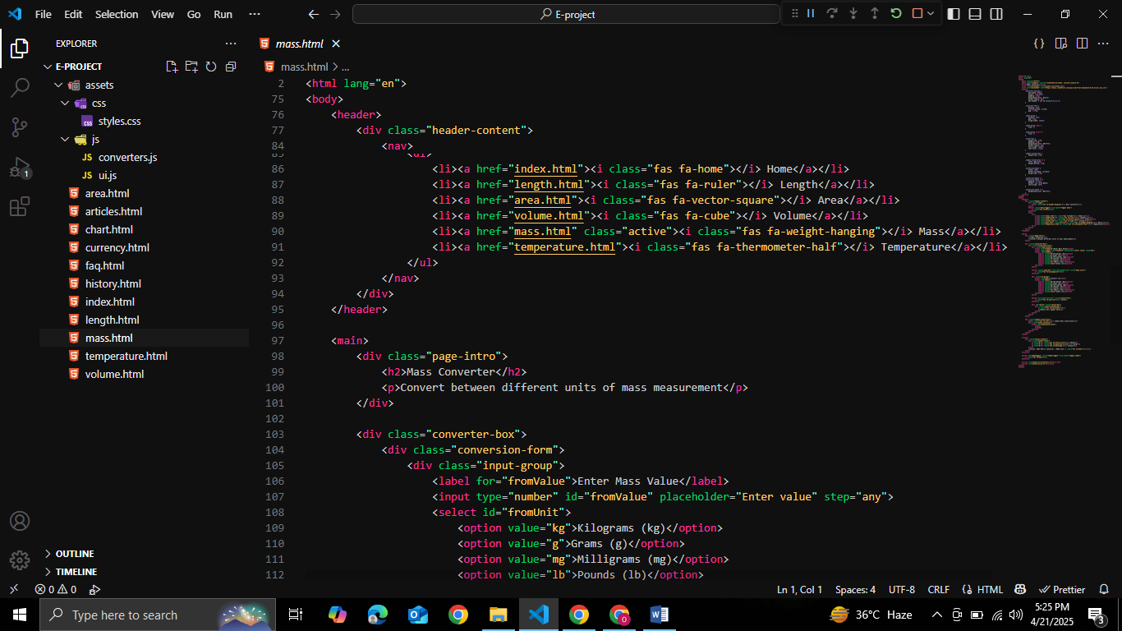

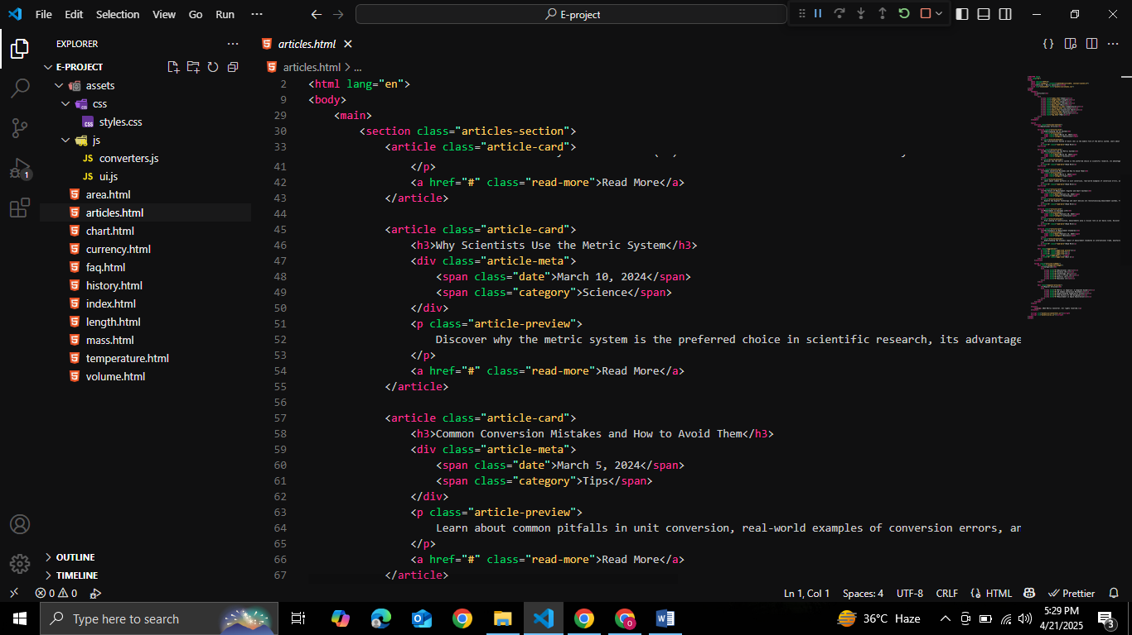

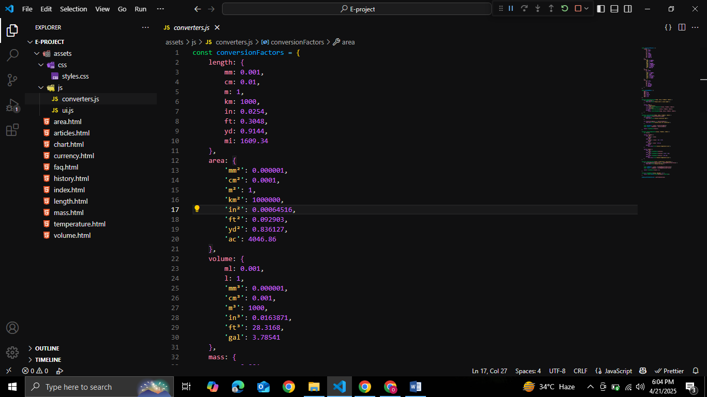

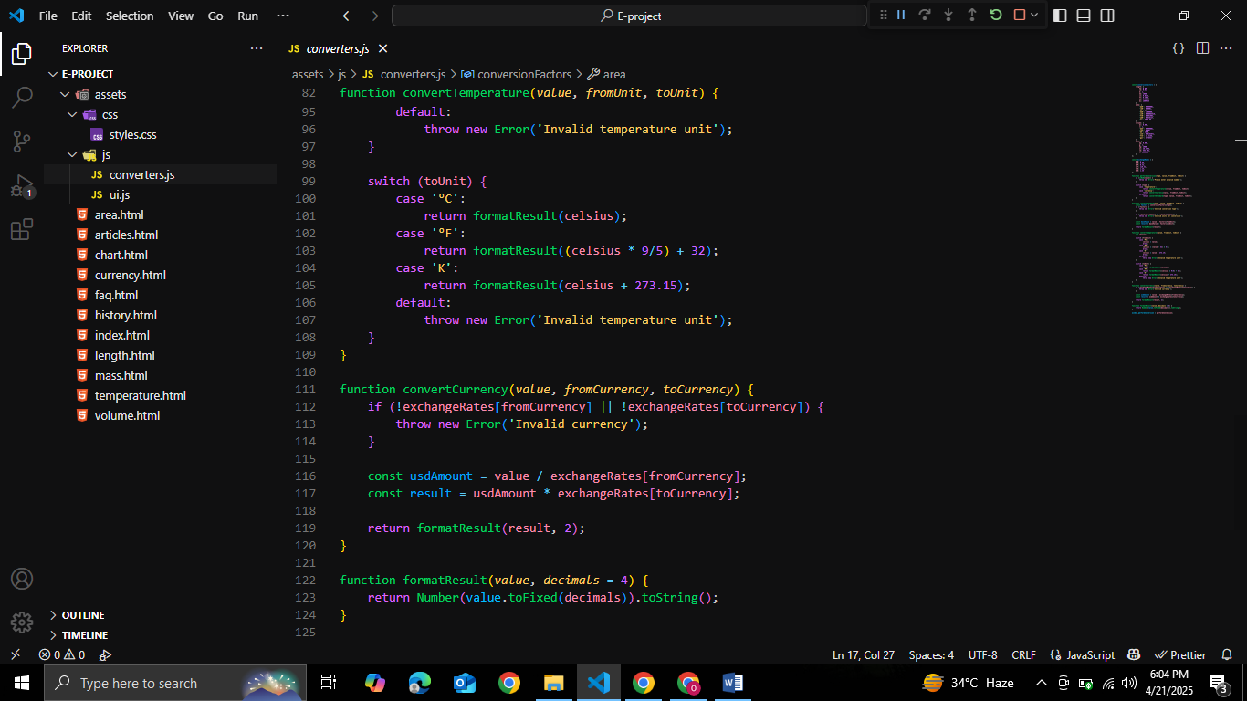

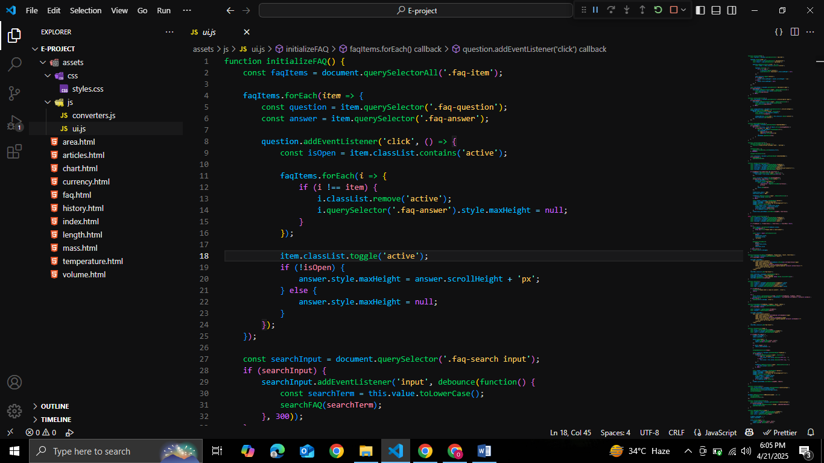

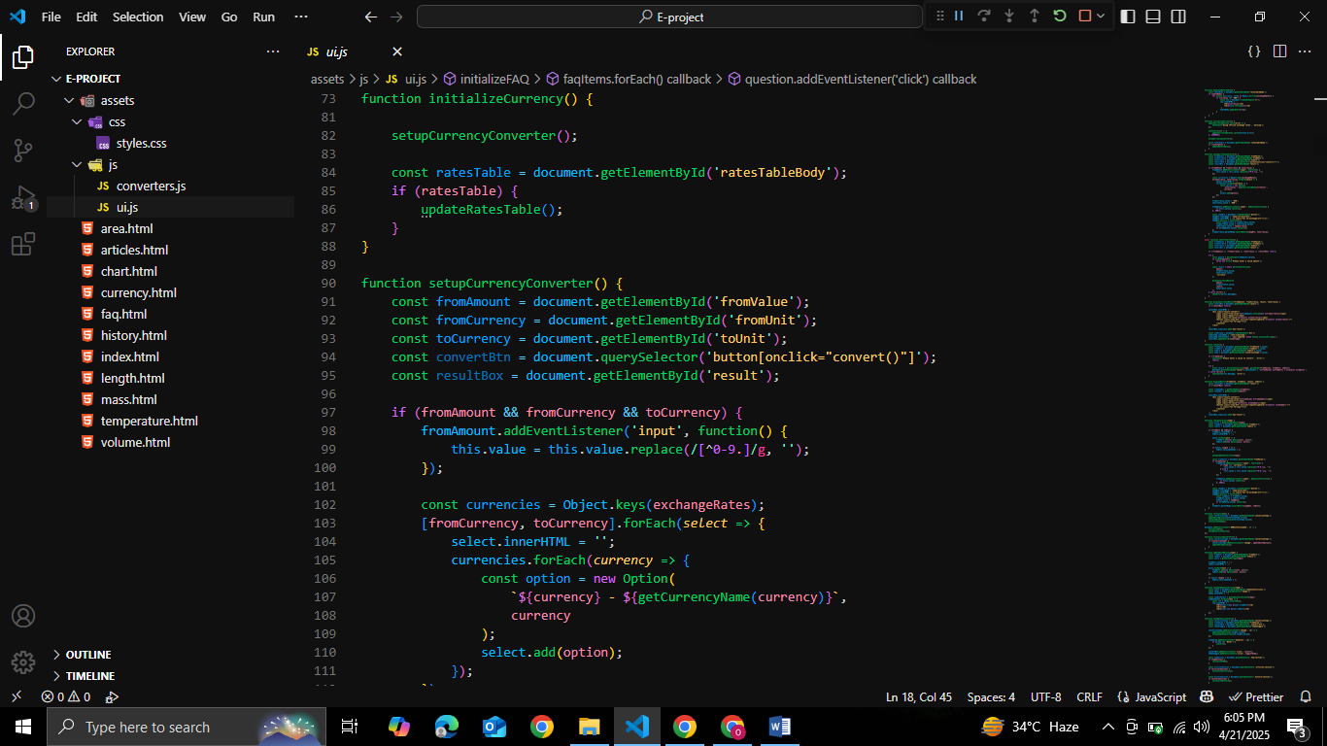

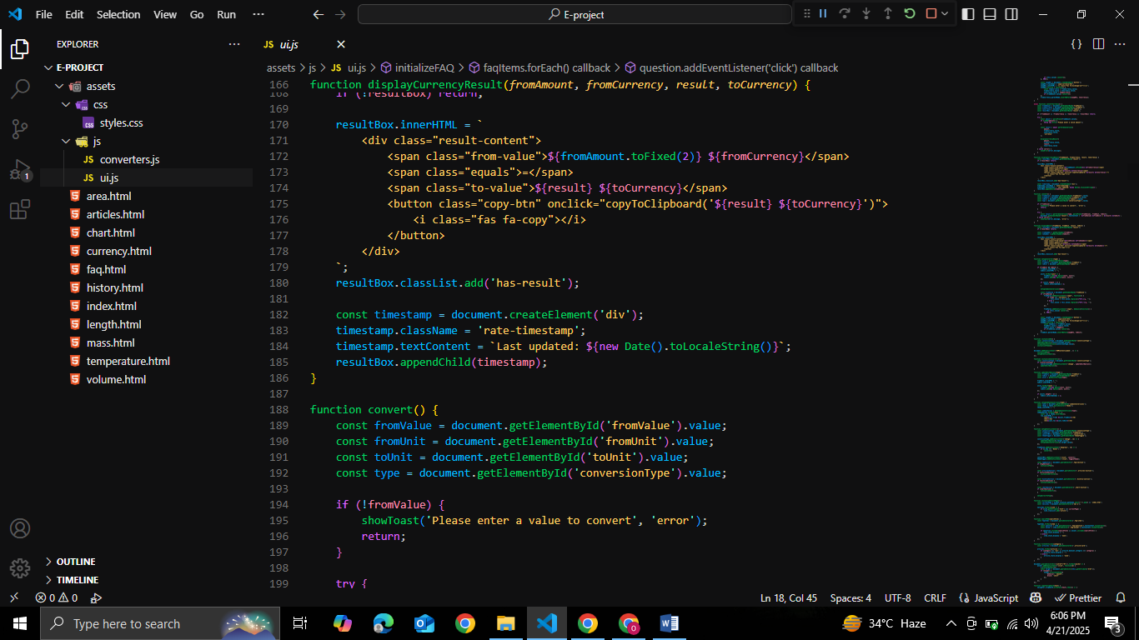

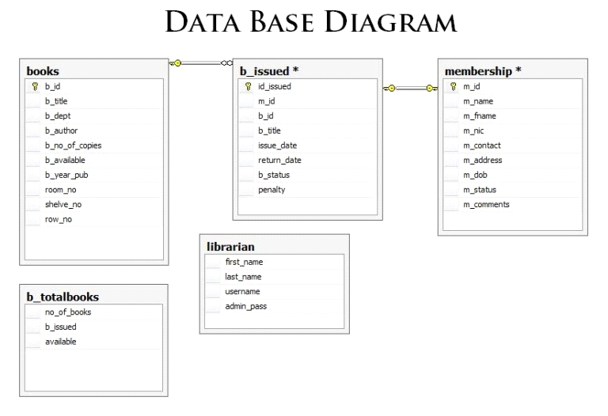
Task Sheet

Project Ref. No. |  | Project Title | Date of Preparation of Activity Plan
S.No. | Task | Kitchen Appliances | Actual Days | Status
1 | Analysis |  | 1 | OK
2 | Design |  | 2 | OK
3 | Development |  | 5 | OK
4 | Testing |  | 1 | OK
5 | Documentation |  | 1 | OK



